PARTT STATE BOARD MEETING IN EAGLE PASS, TEXAS
MARCH 22, 2013

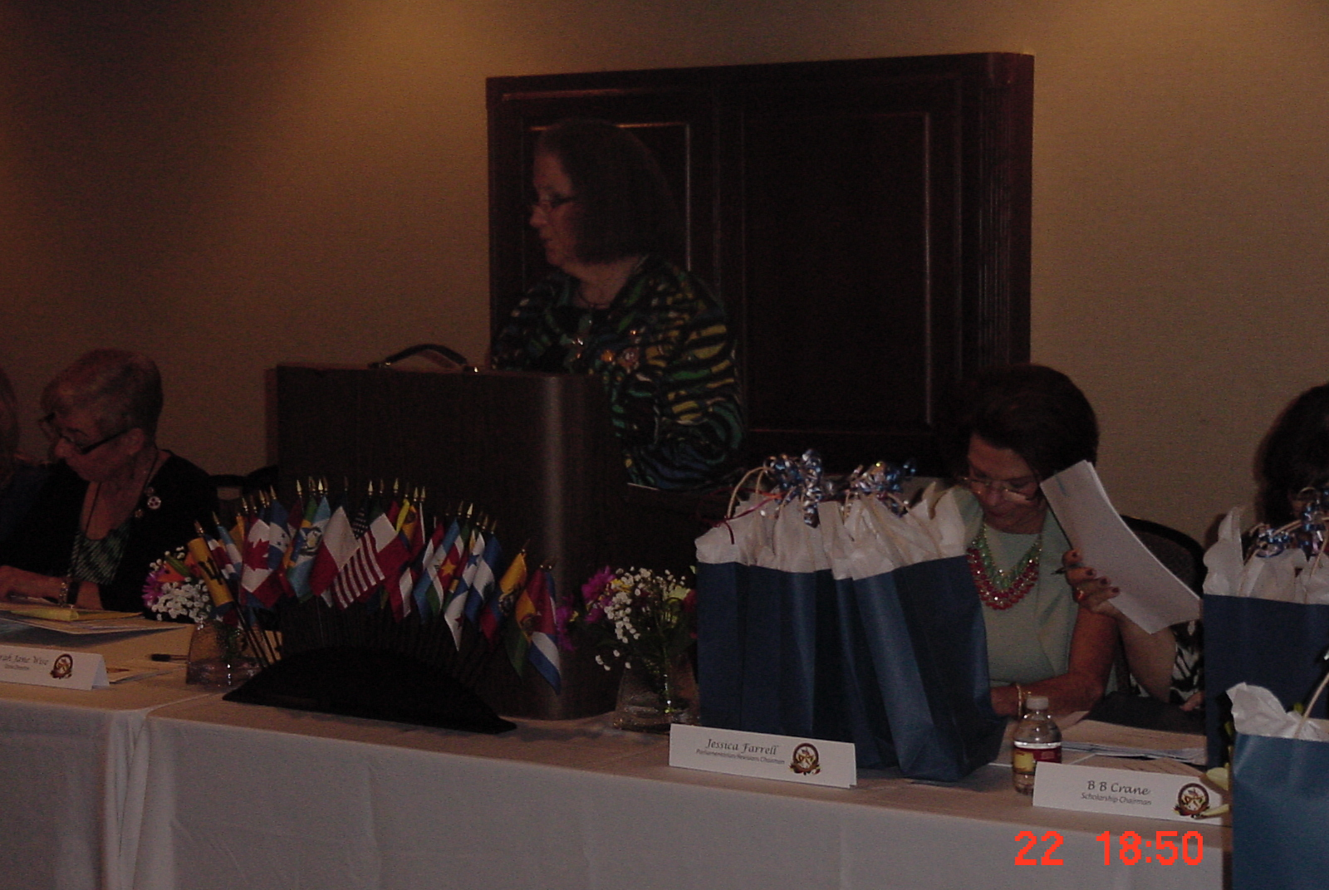
PARTT State Director, Sarah Jane Wise opens the State Board Meeting in Eagle Pass.
(l to r) Martha Stumbo, PARTT Recording Secretary and Alliance Zone I Director, Sarah Jane Wise, and Jessica Farell, PARTT Parliamentarian

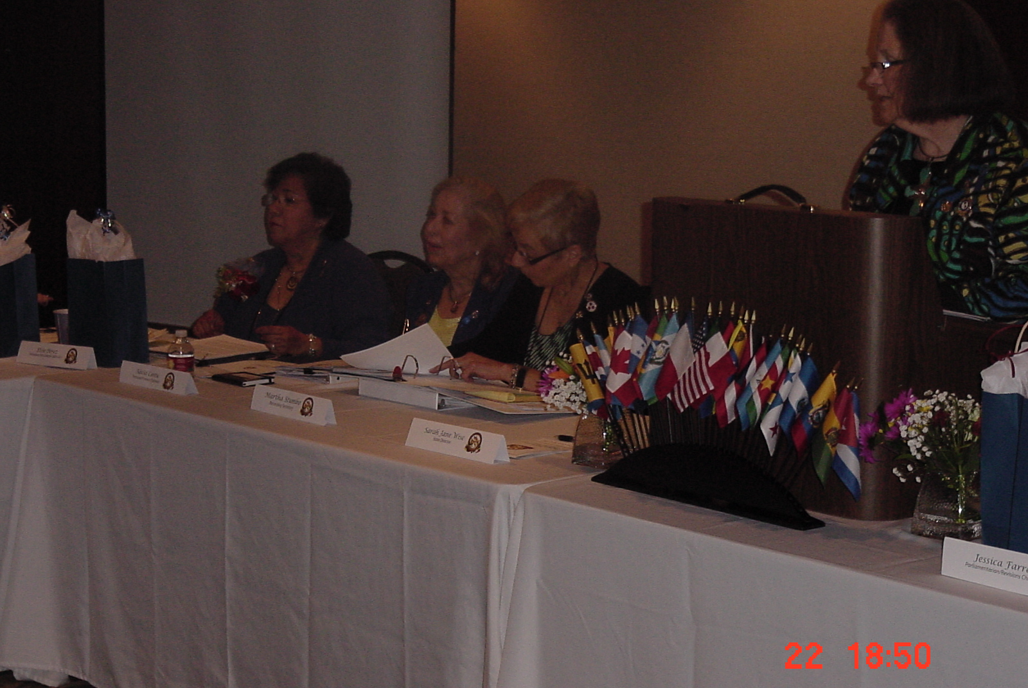
(l to r) Elsie Perez, Alliance Director General and Past PARTT State Director (2009-2011), Alicia Cantu, PARTT State Treasurer, Martha Stumbo, PARTT Recording Secretary and Alliance Zone I Director, and Sarah Jane Wise, PARTT State Director.

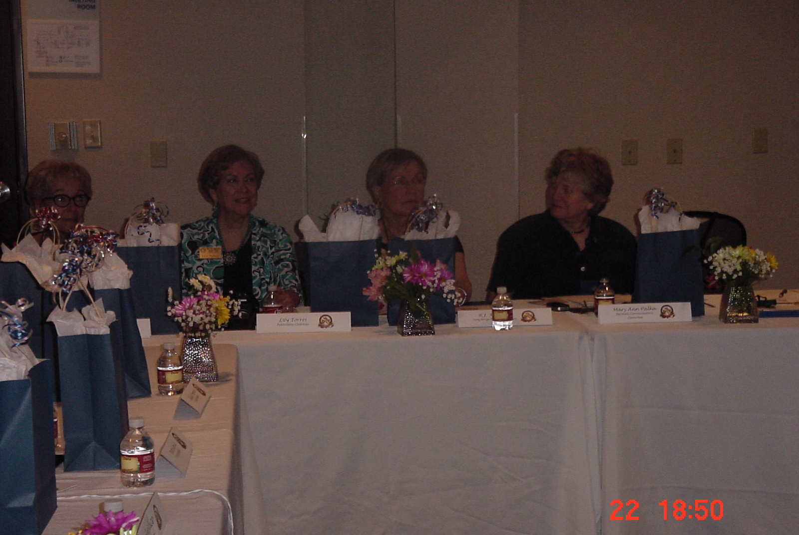
(l tor) Jane Wicker, PARTT Resolutions Chair, Lily Torrez, PARTT Publications Chair,
B. J. Kershaw, PARTT Long Range Planning Committee Member, and Mary Ann Palka, PARTT Web Master

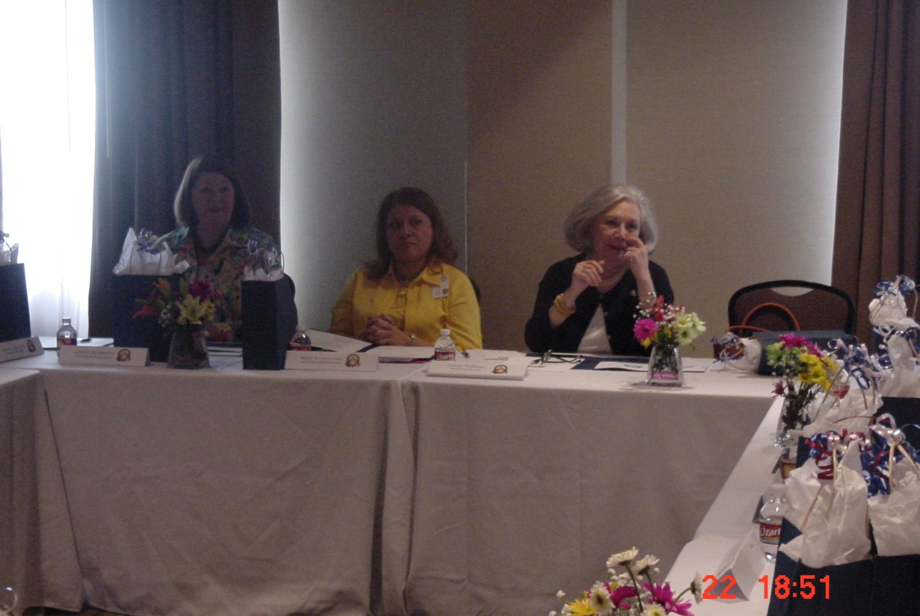
(l to r) Louise Actkinson, PARTT First Associate Director Area B, Margot Arrevalo
Gonzalez, PARTT Second Associate Director Area C,and Sylvia Williams, PARTT
Nominating Committee Chair and Alliance Treasurer

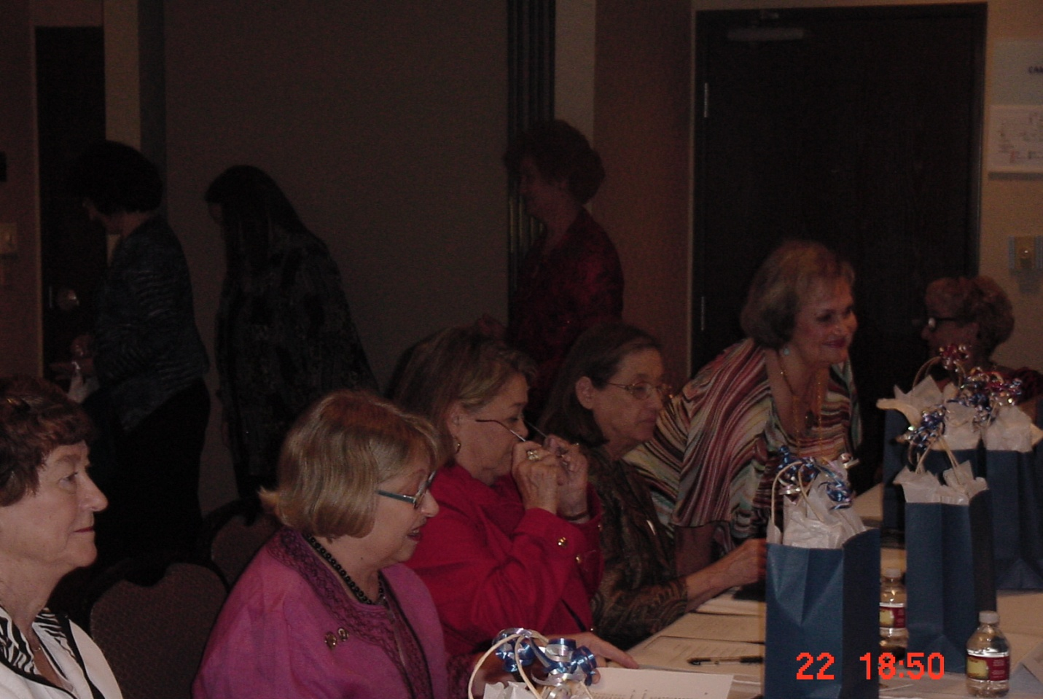
(l to r) Peggy L. Clark, PARTT Past State Director (1997-1999) and Past Alliance Director General (2006-2008), Geri Rice, PARTT Past State Director (2003-2005), Berta Garcia, PARTT Past State Director (2001-2003), Gladys Simpson, PARTT Past State Director (1991-1993) and Past Alliance Director General, and Carmen Guerra, Alliance Parliamentarian and Past Alliance Director General

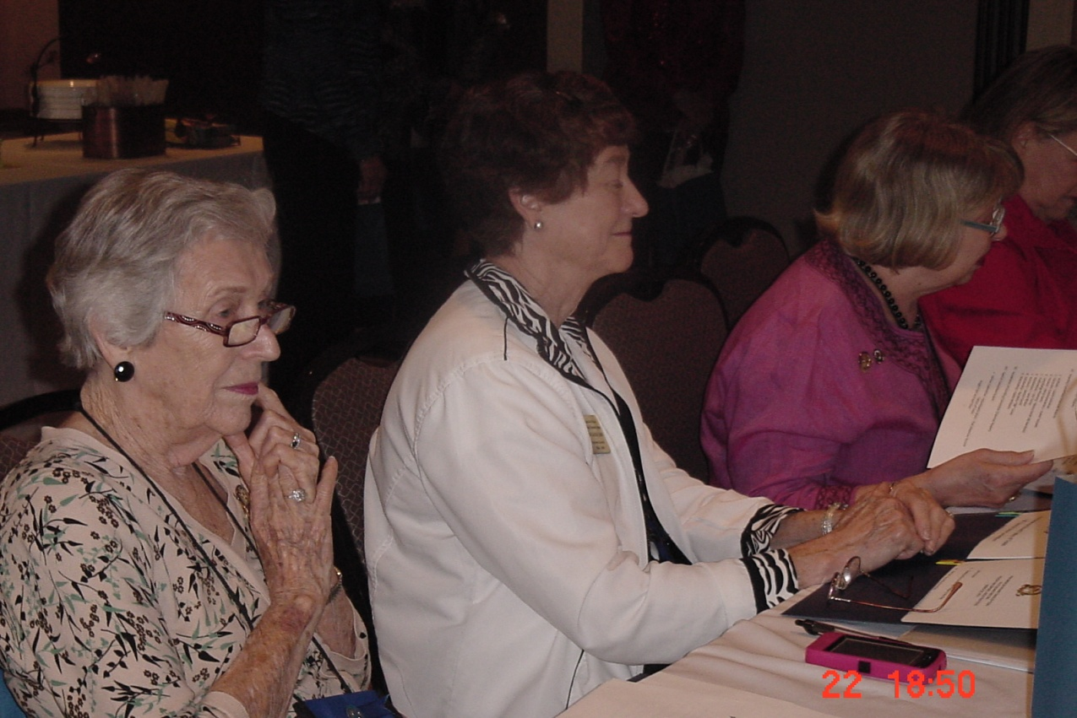
(l to r) Frances Metcalf, PARTT Past State Director ( 1987-1989), Peggy L. Clark, PARTT
Past State Director (1997-1999) and Past Alliance Director General (2006-2008)
and Geri Rice, PARTT Past State Director (2003-2005)

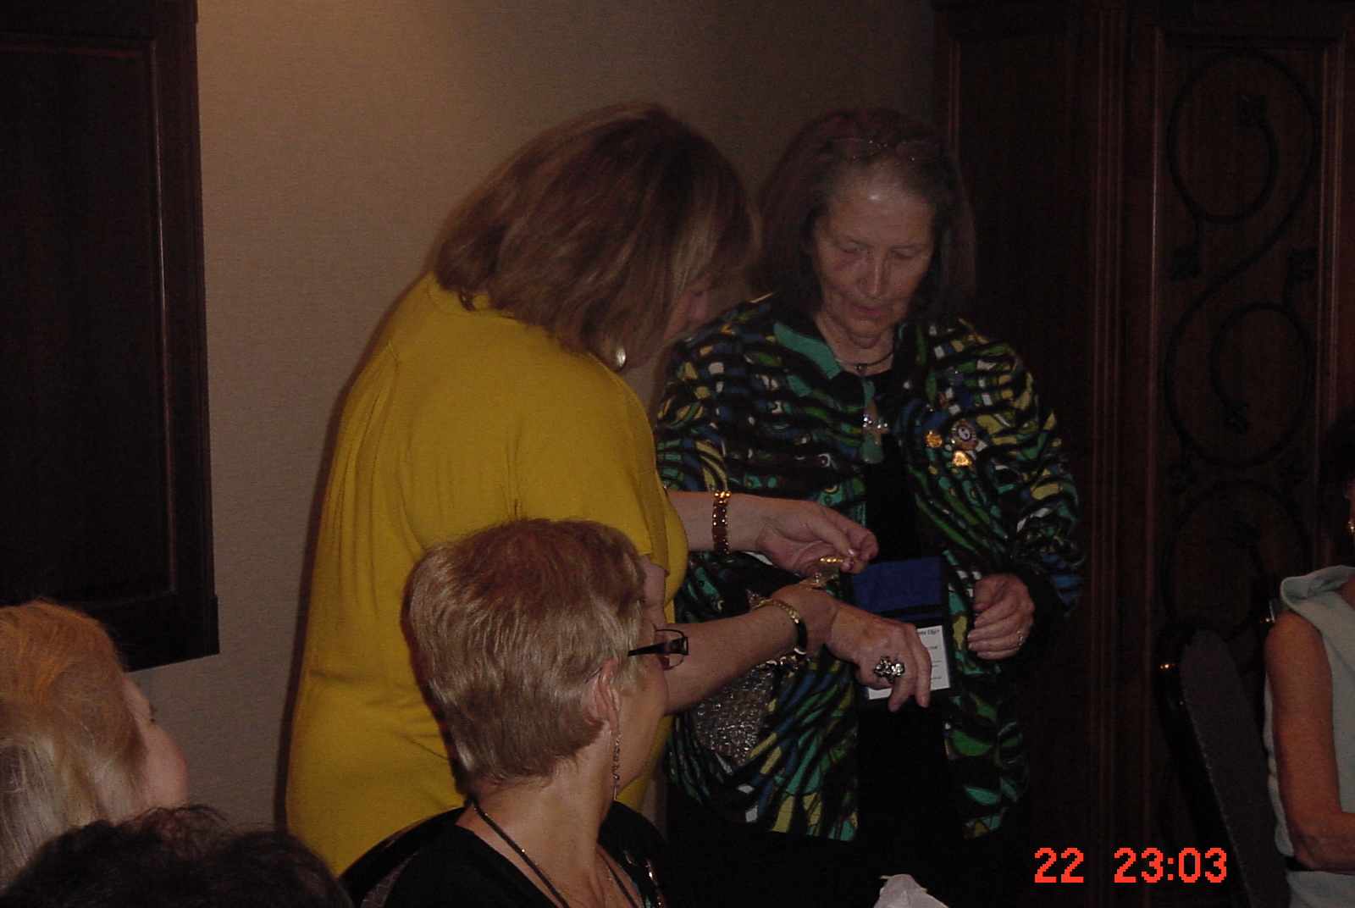
(l to r) Yolie Calley, PARTT Corresponding Secretary presents Sarah Jane Wise, PARTT State Director with a gift from the PARTT State Board

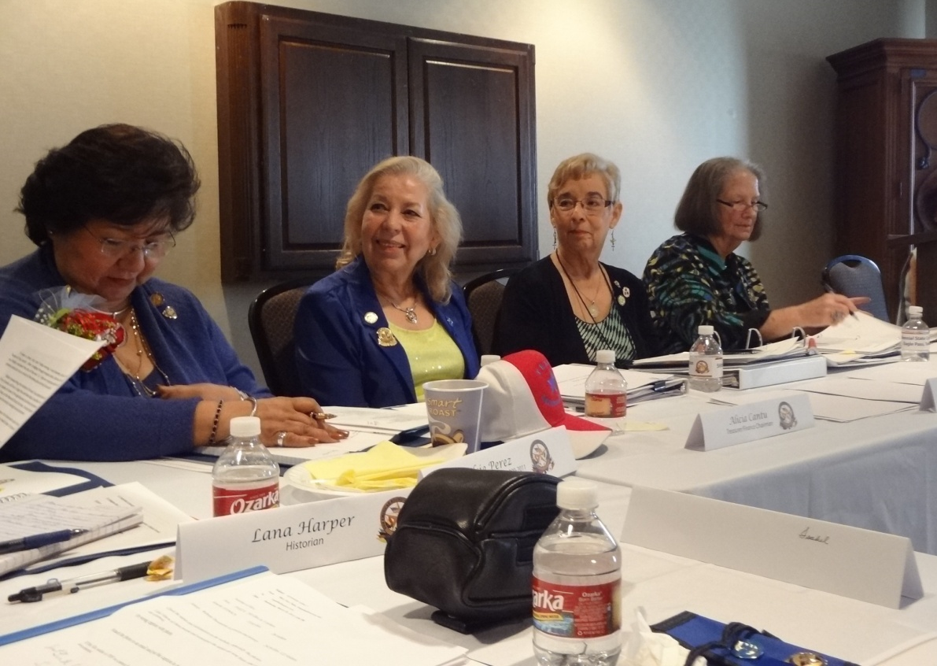
(l to r) Elsie Perez, Alliance Director General and Past PARTT State Director (2009-2011), Alicia Cantu, PARTT State Treasurer, Martha Stumbo, PARTT Recording Secretary and Alliance Zone I Director, and Sarah Jane Wise, PARTT State Director.

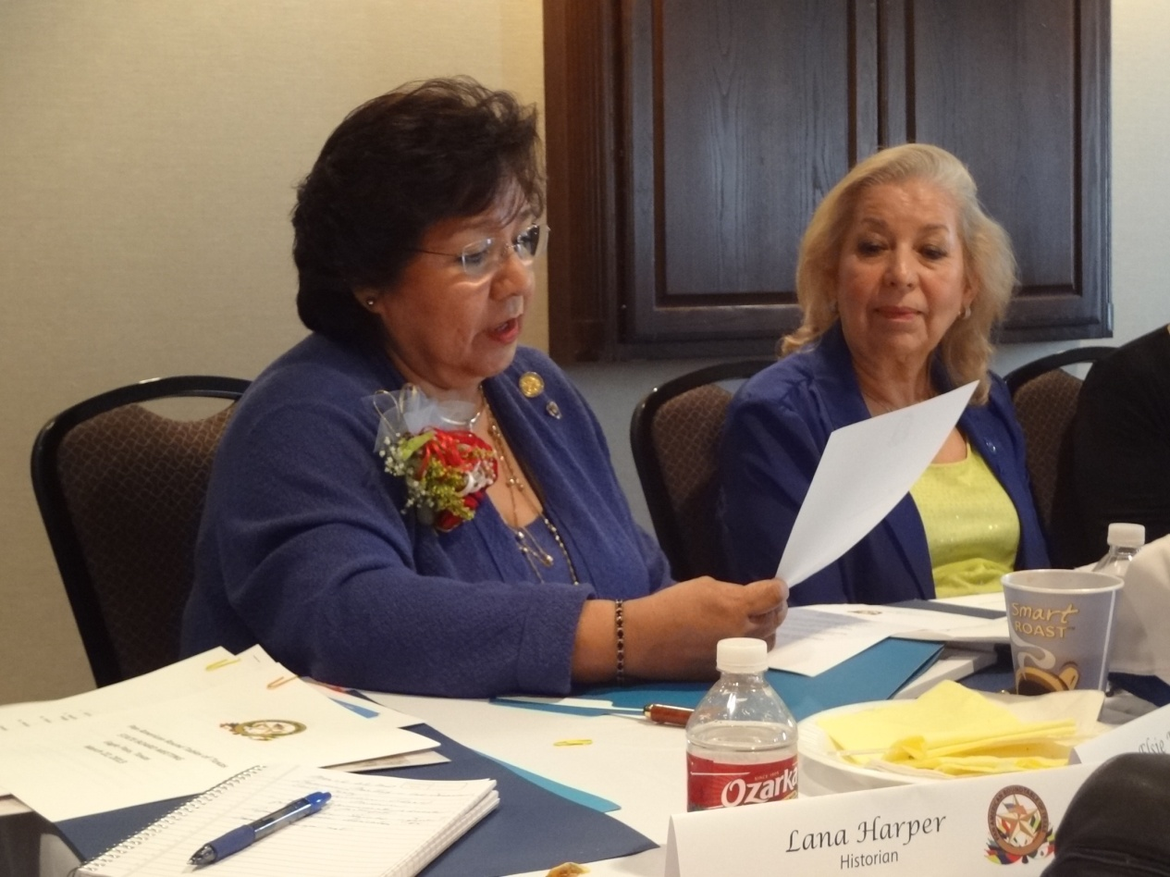
Elsie Perez, Alliance Director General and Past PARTT State Director (2009-2011), Alicia Cantu, PARTT State Treasurer

Return to Convention Photo Gallery…

